Rounds Information System
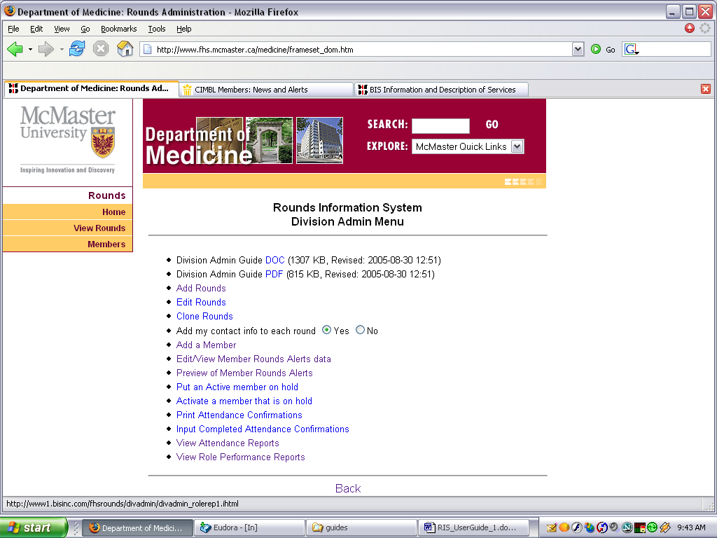
Division Administrator Guide

Certain members have Division Admin and/or System Admin accounts. Those with Division Admin accounts will have a link to the Division Admin Menu available on their Member Menu, as can be seen on the right.

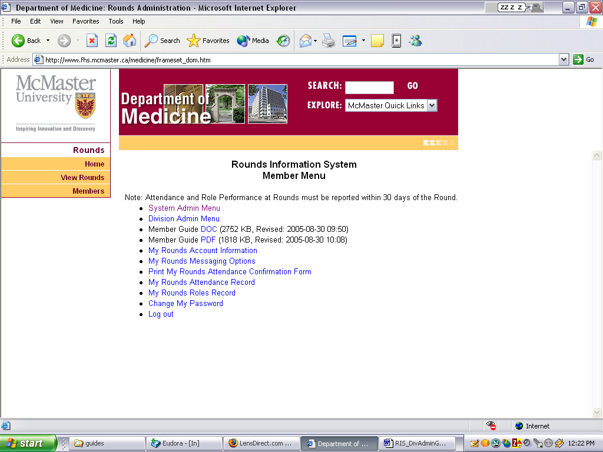

The Division Admin menu has links to this guide, to Add Rounds, to Edit Rounds and to Clone Rounds. In addition, a Division Admin can cause the system to include their contact information automatically on each Round they enter.

Adding and managing member accounts and maintaining attendance records can also be done from this menu.

The Add Rounds screen first requests the scheduled date of the Rounds you are about to add.

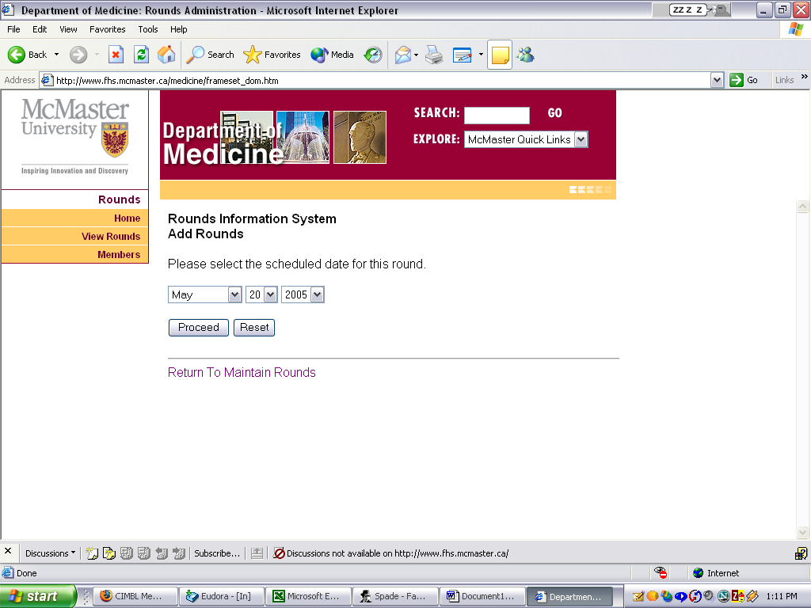

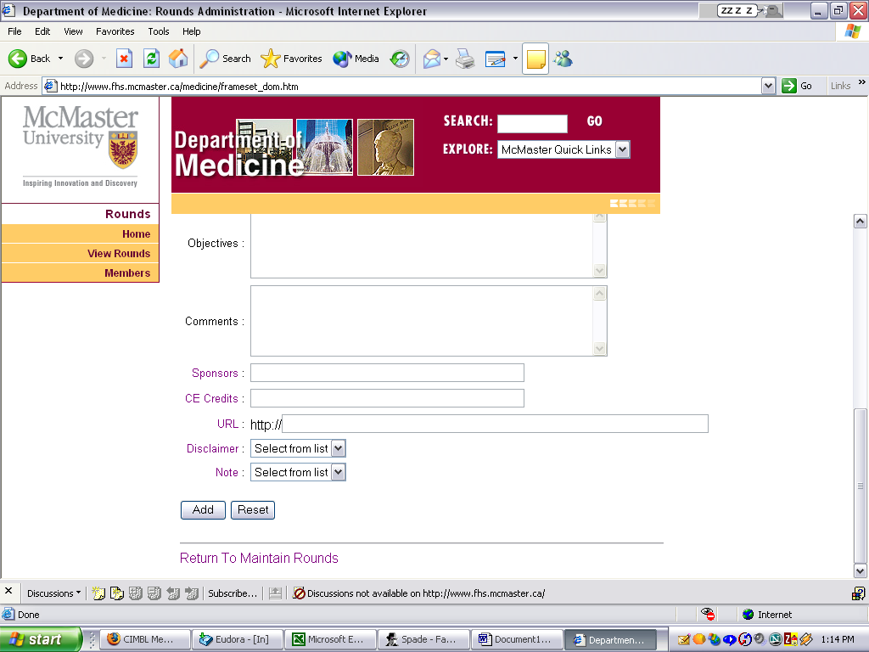
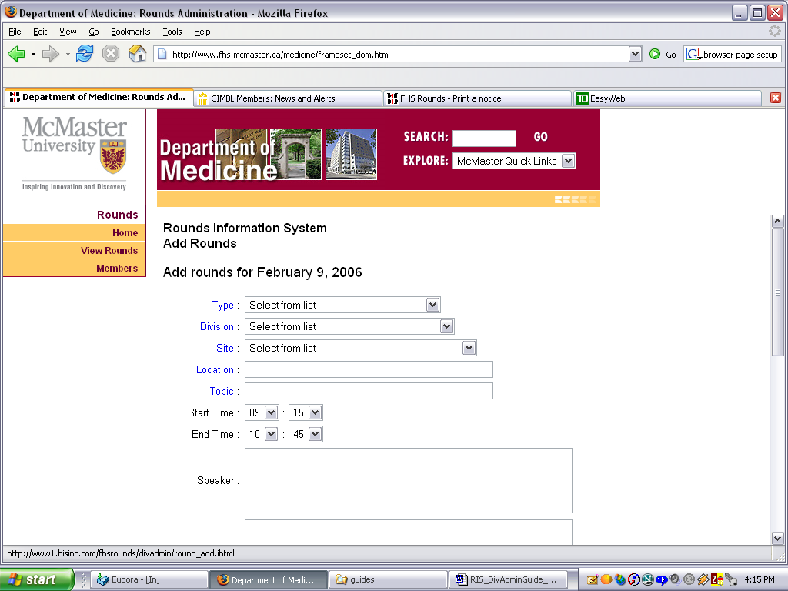
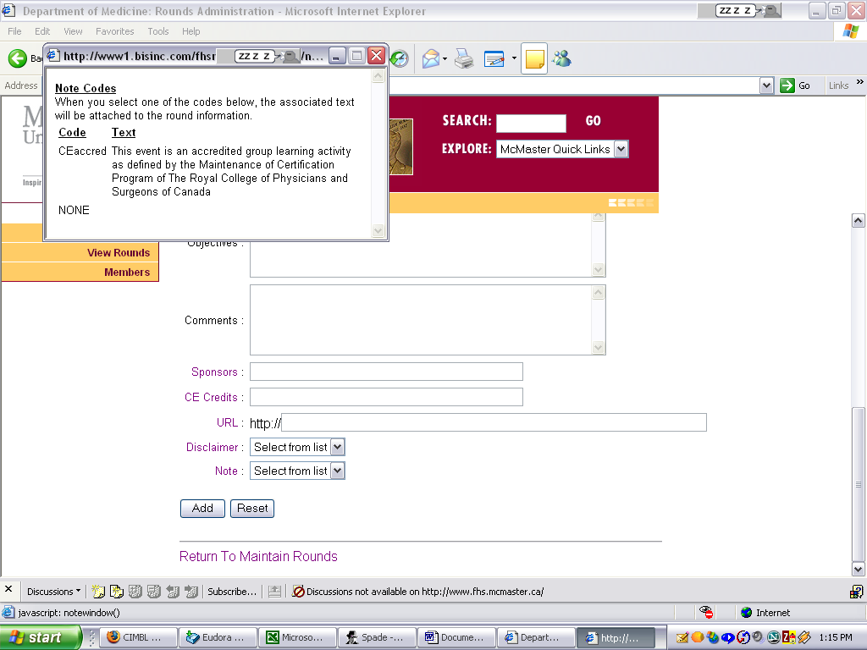

Adding the Round is then simply a matter of completing the form.

You can set your own default Start Time and End Time for Rounds in your My Rounds Account Information Screen.

Click the Add button when the form is complete and the Round will be submitted to the database.

To add a Round that is very similar to one already added, use the Clone Rounds link instead of Add Rounds.

Certain fields within the form have names which are hyperlinks to additional information. For example, on the right is shown the result of clicking on the field name Note.

When the Add button is clicked, the Round is immediately available for display on the web site and appropriate members are informed by email and/or cell phone.

To edit a Round, select the Edit Rounds link from the menu and then select the Round you wish to edit. The only Rounds that are displayed will be Rounds that you have entered or that have been assigned to you by the System Admin or by the Division Admin who originally entered them.

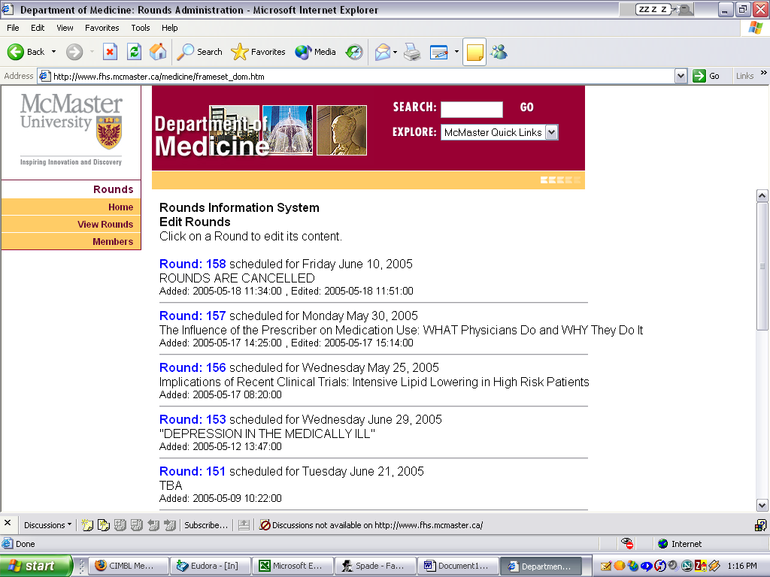
All of the fields that were originally entered except for the scheduled date are available to be edited, in order to make corrections or updates wherever necessary. To change the scheduled date of a Round, you must Cancel the Round and then Add it as a new Round.

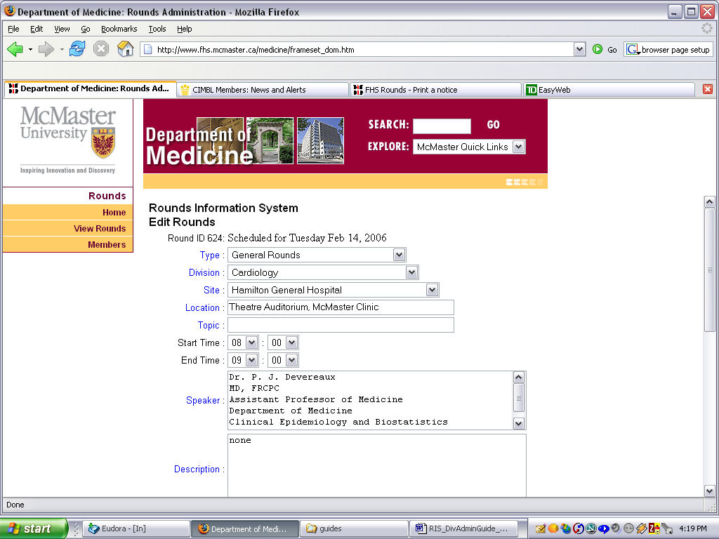
Note that this is where you can cancel a Round when necessary. Simply click the Yes radio button next to “Is it Cancelled?” and then click Save Changes.

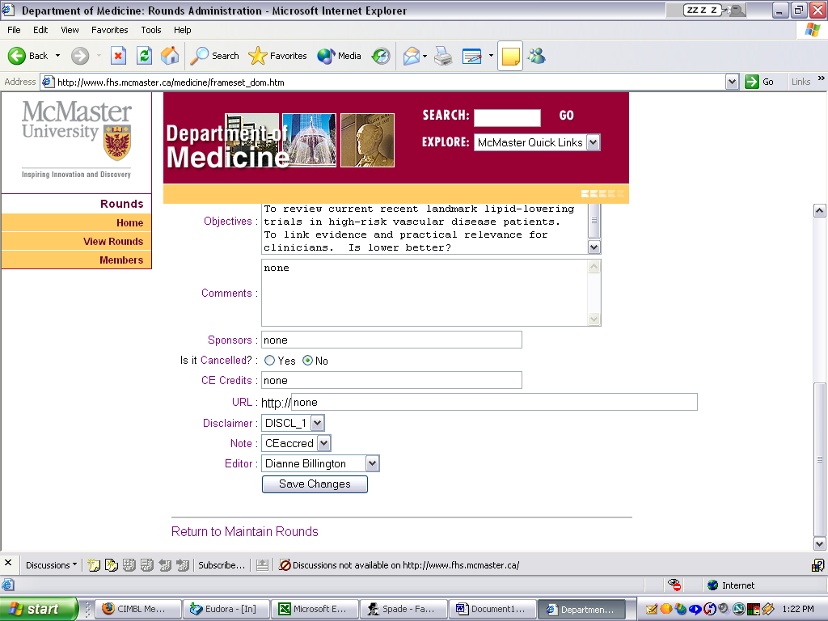
This is also where you can assign the responsibility for this Round to someone else by changing the Editor.

When your changes are complete, click the Save Changes button and the new information will be immediately available on the web site and communicated to the appropriate members by email and/or cell phone.
Adding and Managing Member Accounts
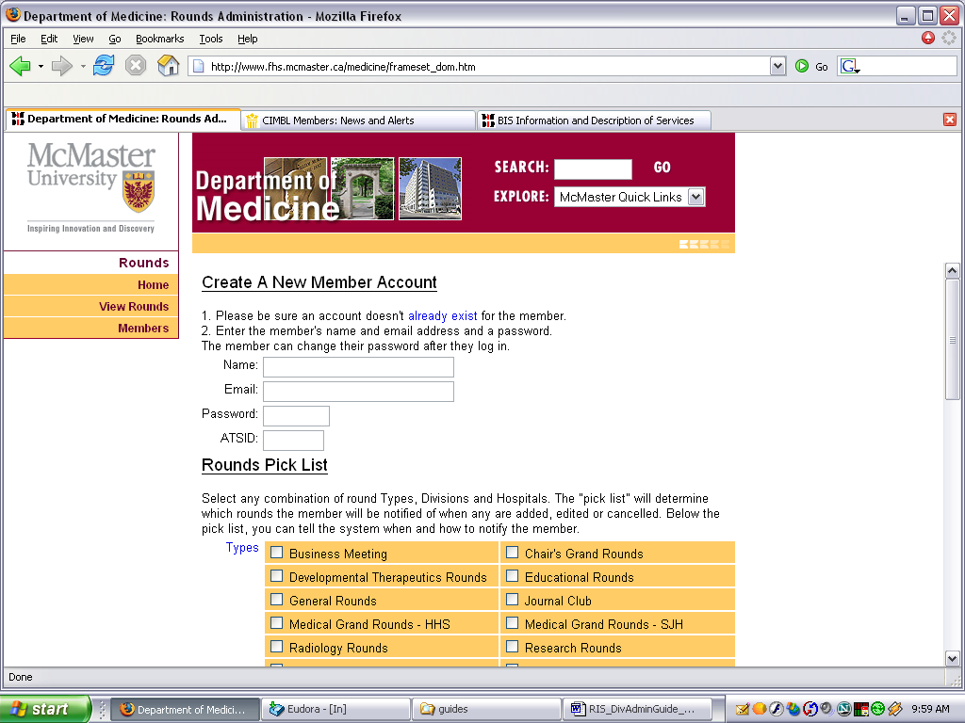
When a Division Admin adds a member they become the “handler” for that account. The Division Admin can then edit the Rounds Messaging for that account as well as putting the account on hold and releasing the hold. The System Admin can re-assign the member account to any other handler if necessary, or set the account to “no handler” status, which means the member must manage their own account.

It is essential when adding a new member account that you ensure the member does not already have an RIS account, possibly under a different email address. Click on the already exist link to see an alphabetical list of all current RIS members and the email addresses used to create their accounts.

The Division Admin can set up the Rounds Pick List and other notification parameters or simply add the account and let the member set up their own preferences when they log in.

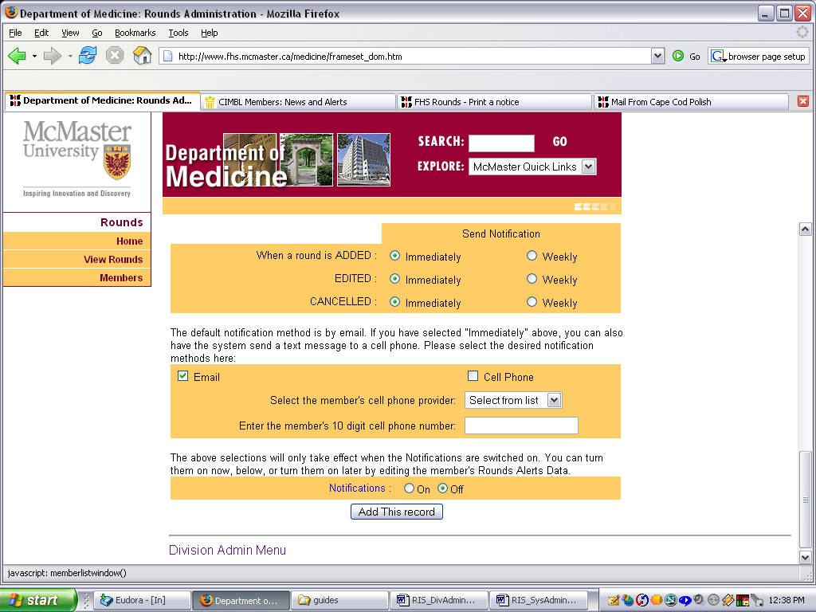
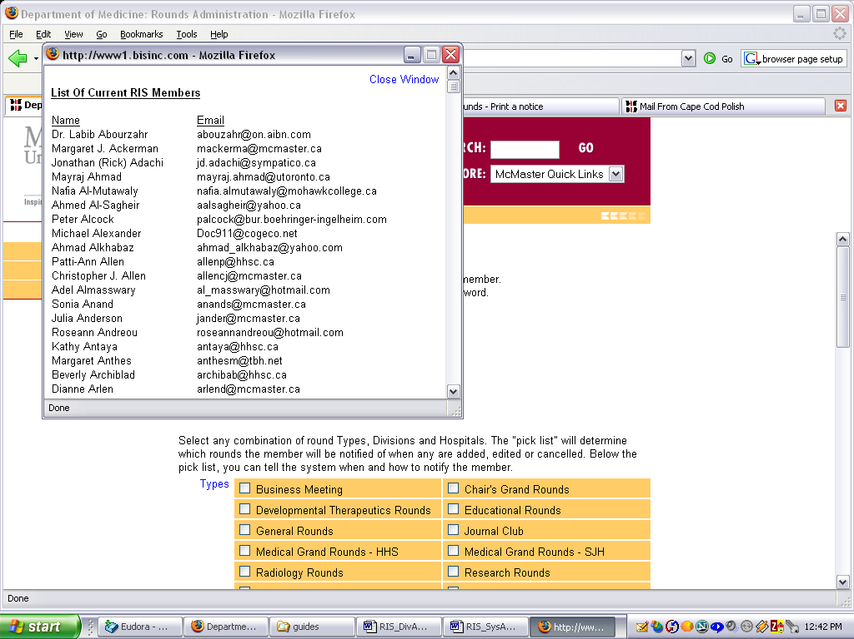
The notifications can be left OFF or turned ON at this time. When the record is added, the member will be immediately sent a welcome message informing them of their new account, their username and password and whether their notifications are turned ON or OFF.

The new member also receives a link to the Member Guide.

If the email address used for the new account is invalid, the system admin will receive the bounced welcome message.

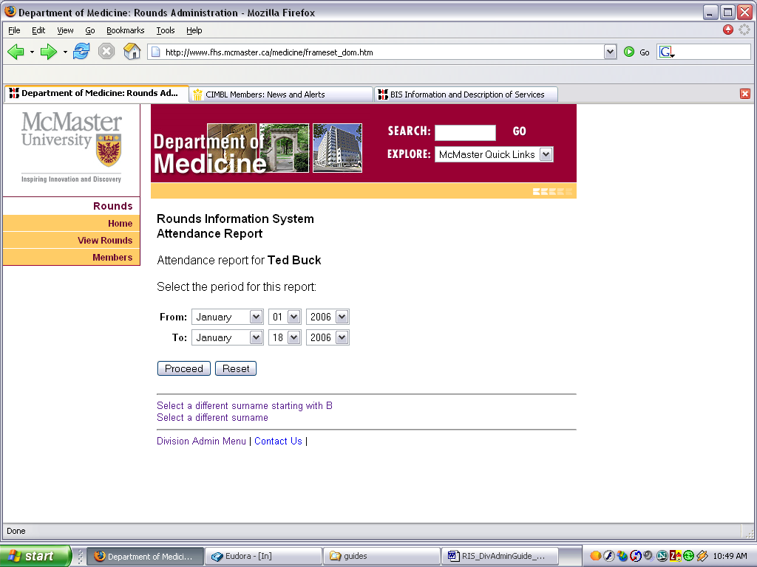

If a member is having difficulty setting up their account, then the Division Admin can select Edit/View Member Rounds Alerts data from the Div Admin menu and assist with the set up.

The Preview of Member Rounds Alerts will display who will receive notifications when Rounds are added, edited and cancelled.
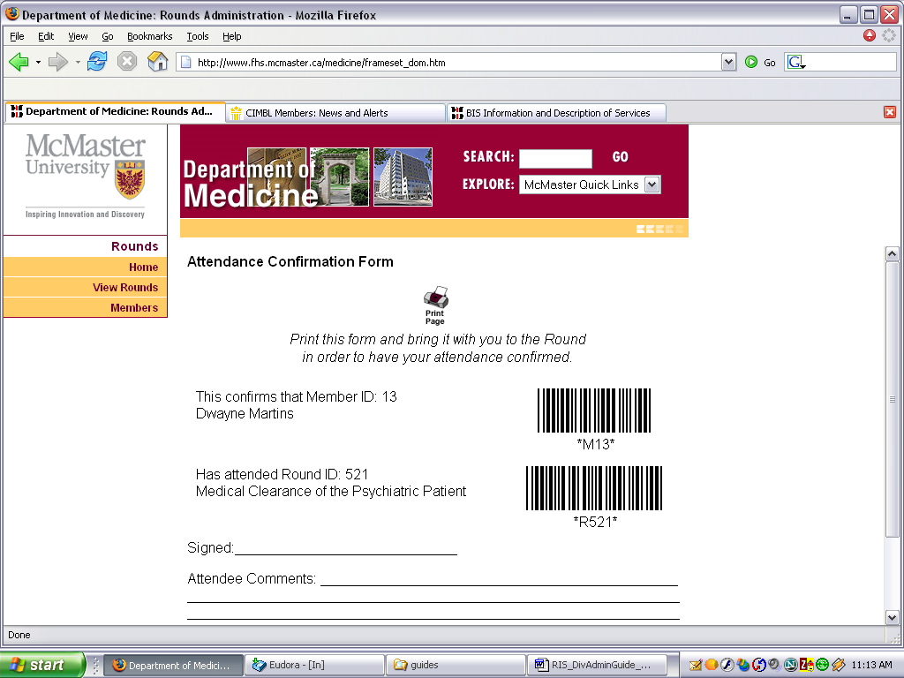
Putting an account on hold will cause the system to ignore the account without affecting any of the account setup. A member cannot log in if their account is on hold and the system does not send any notifications to such accounts.

The Div Admin can print Attendance Confirmations for members if necessary. They can also input the completed confirmations if for some reason the confirmation could not be scanned into the system during the actual Round.

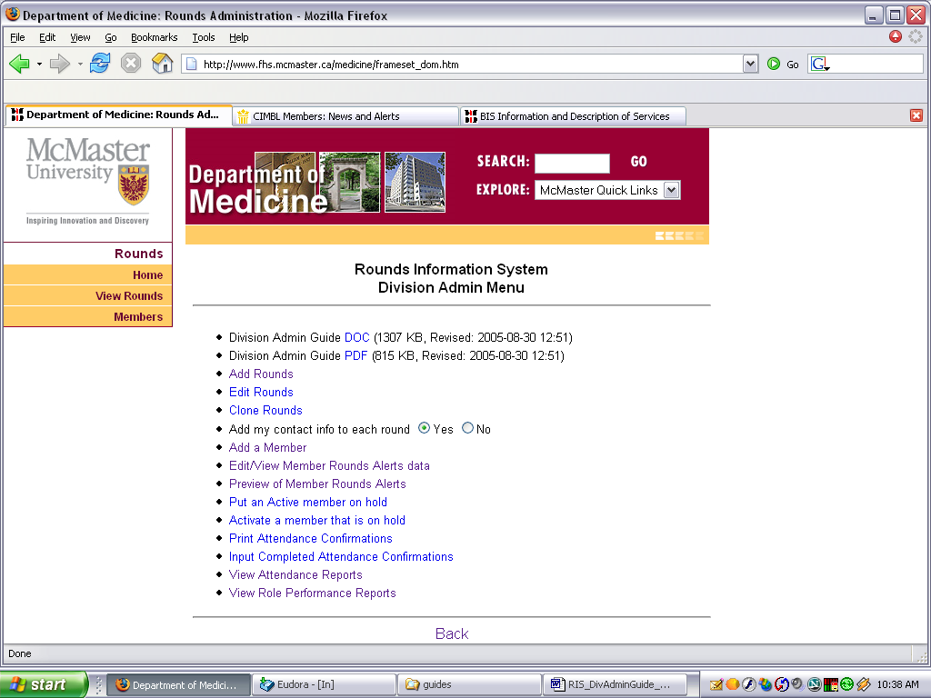

They can also view and print Attendance Reports and Role Performance Reports for any time period.

Attendance reports show the confirmation date and time stamps, warnings if confirmations have not been received, and any comments the member submitted.

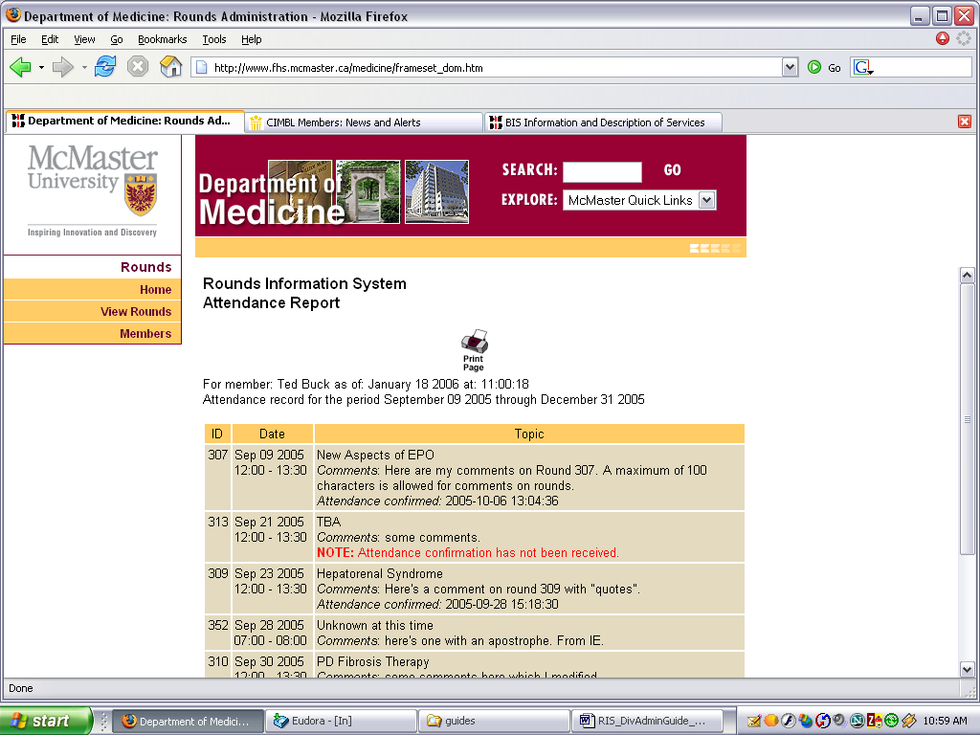
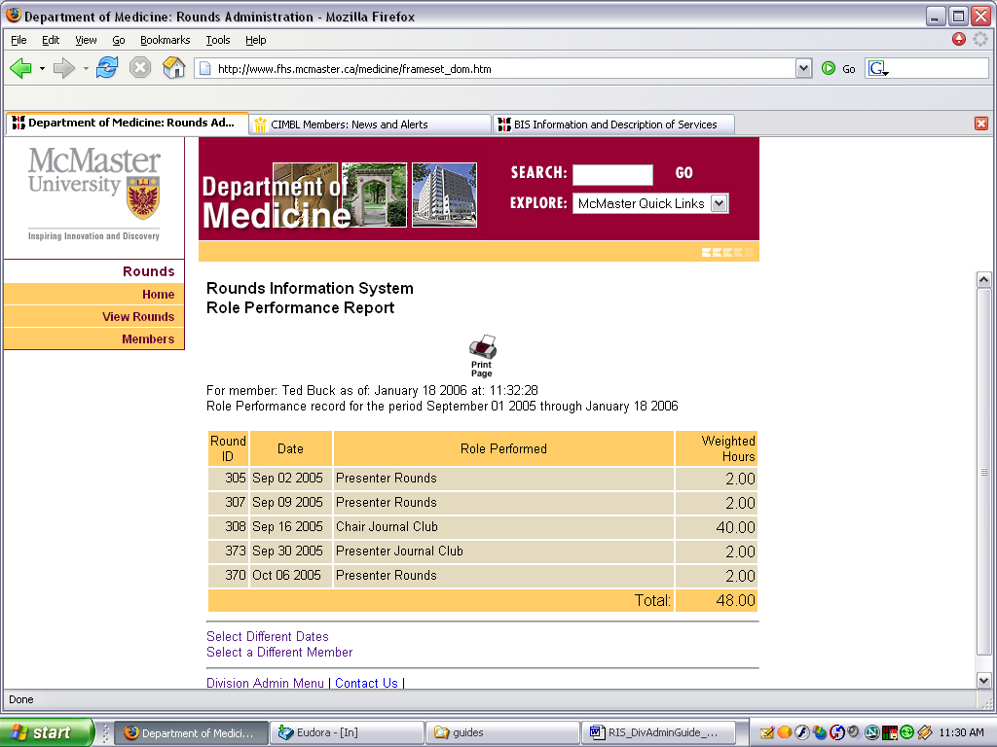
Similarly, Role Performance reports can be run for any time period, displaying the roles performed and weighted hours for those roles.

