Rounds Information System

Member Guide

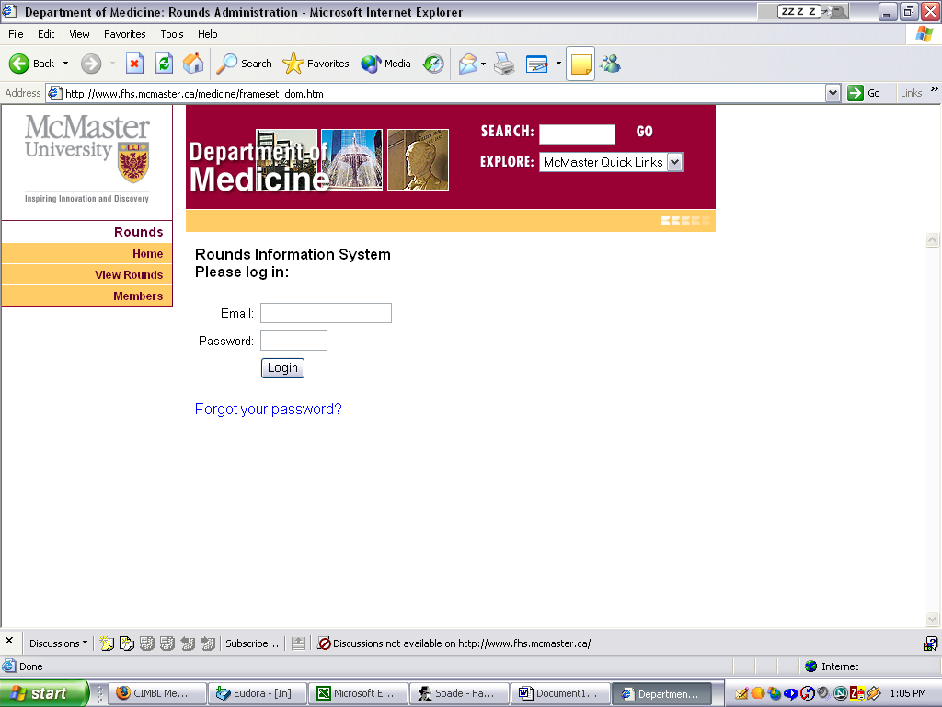
When an RIS account is created for you, an email message is sent welcoming you to the system and telling you your username, which is your email address, and your password. The message also informs you if your Round notifications are turned ON or OFF and it contains a link to this Member Guide. When you log in, you are able to set up the system to inform you when certain Round events occur as well as maintain your attendance and roles-performed records for all Rounds on the system.

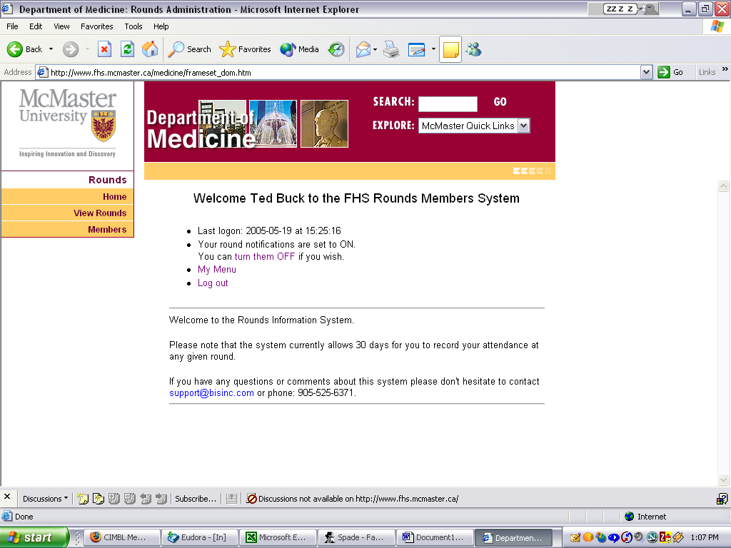

If you forget your password or simply want to change it, the system can generate a new one and email it to you. If you do not have Division Admin rights or System Admin rights, you are allowed to edit your password in the My Rounds Account Information screen. You can set it to be whatever you wish, to a maximum of 9 characters in length.

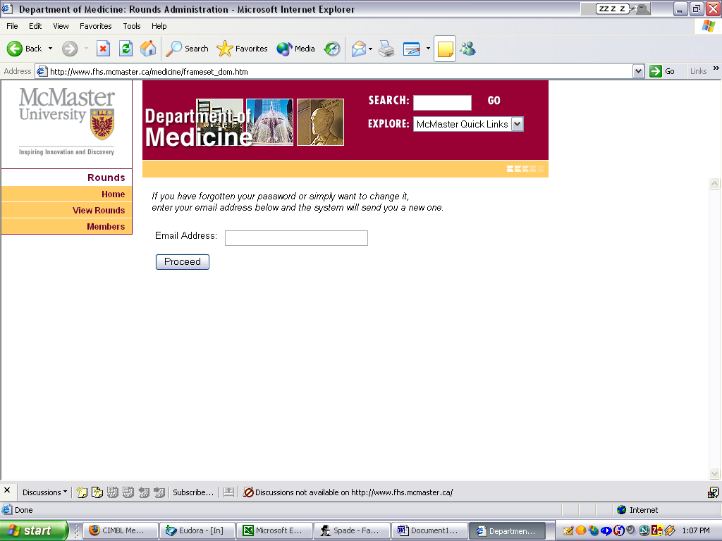
Once you successfully log in, a welcome screen similar to the one shown on the right will appear. The System Administrators may post bulletin board messages here. If there is something wrong with your account setup you will see ALERT messages here warning you of the problem.

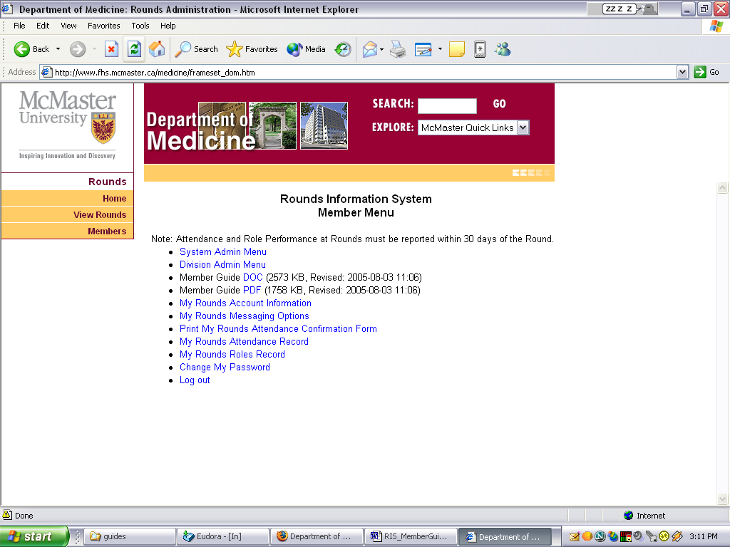
When you select My Menu from the welcome screen, the page on the right will appear.

If you do not have System Admin rights you will not see the System Admin Menu link.

If you do not have Division Admin rights you will not see the Division Admin Menu link.

The Member Guide link is this guide.

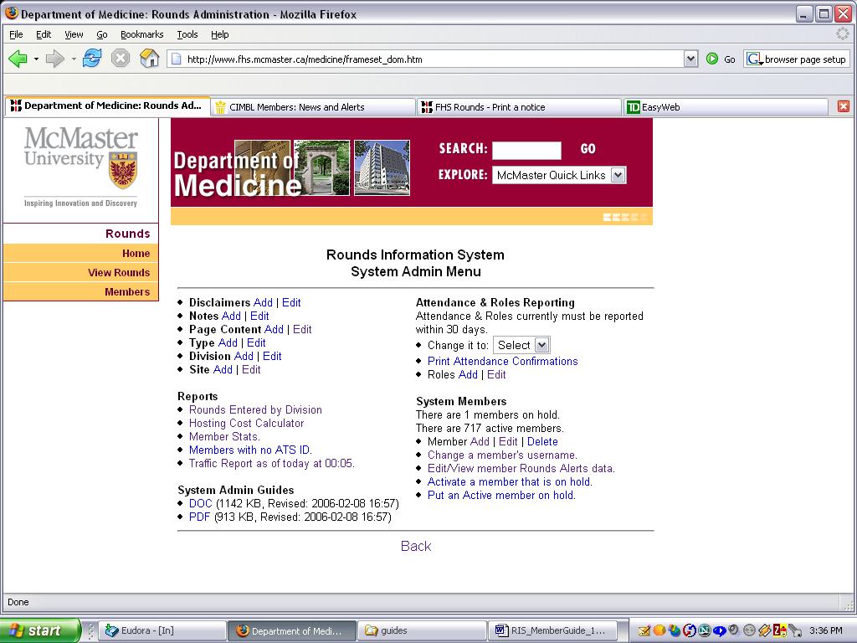
The System Admin Menu is shown on the right.

The Division Admin Menu is shown on the right. Your Division Admin can assist you with setting up your Rounds Messaging and other aspects of your account.

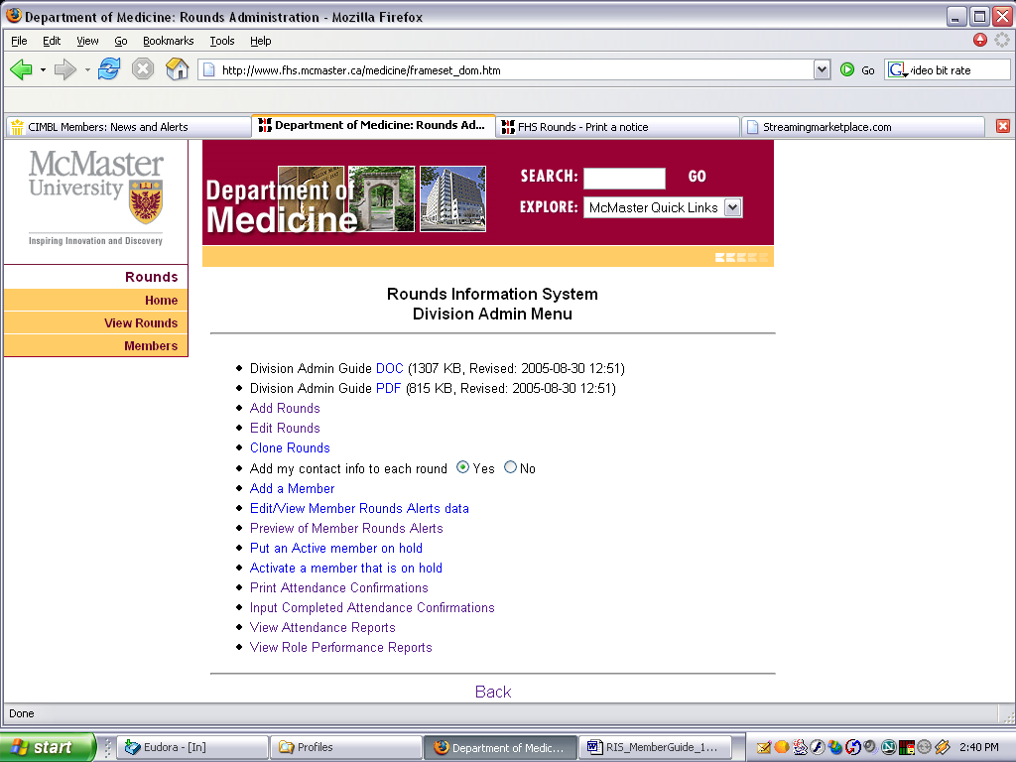
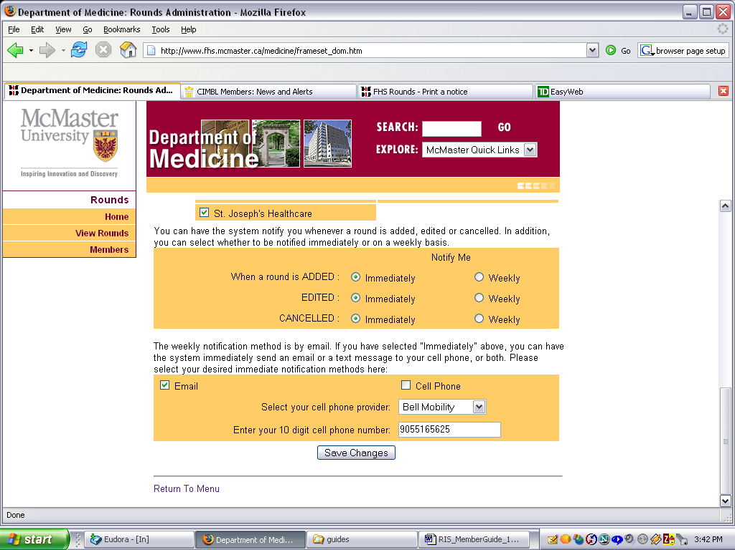
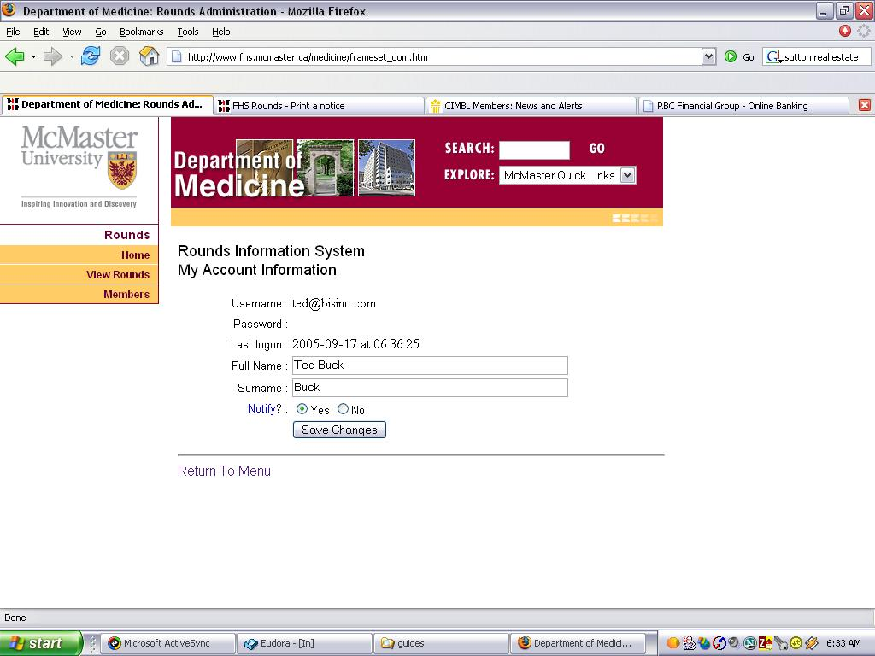
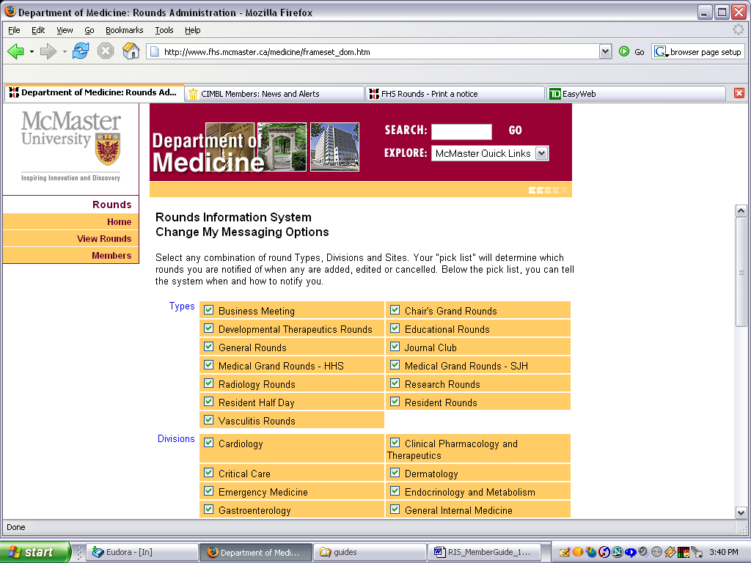
The My Rounds Account Information screen is shown at the right.

When a member account is created, the last word in the name is assumed to be the surname. It is used solely for alpha sorting of member lists and you can change it here if it is not correct for your name.

Once you have set up your Messaging Options, the notifications can be toggled on and off here at any time.

You can control which Rounds you are notified of by selecting the Types, Divisions and Sites in your Messaging Options screen.

A member must select at least one Type, one Division and one Site
and have Notifications turned on in order to receive any notifications.

You also instruct the system how and when to notify you whenever Rounds have been Added, Edited
or Cancelled.
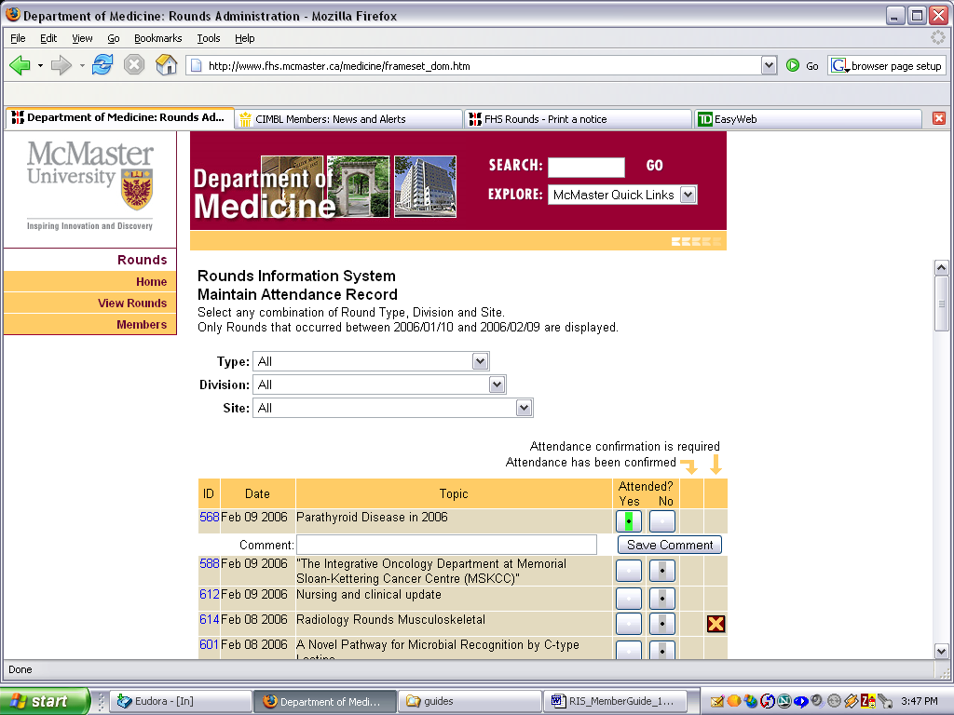
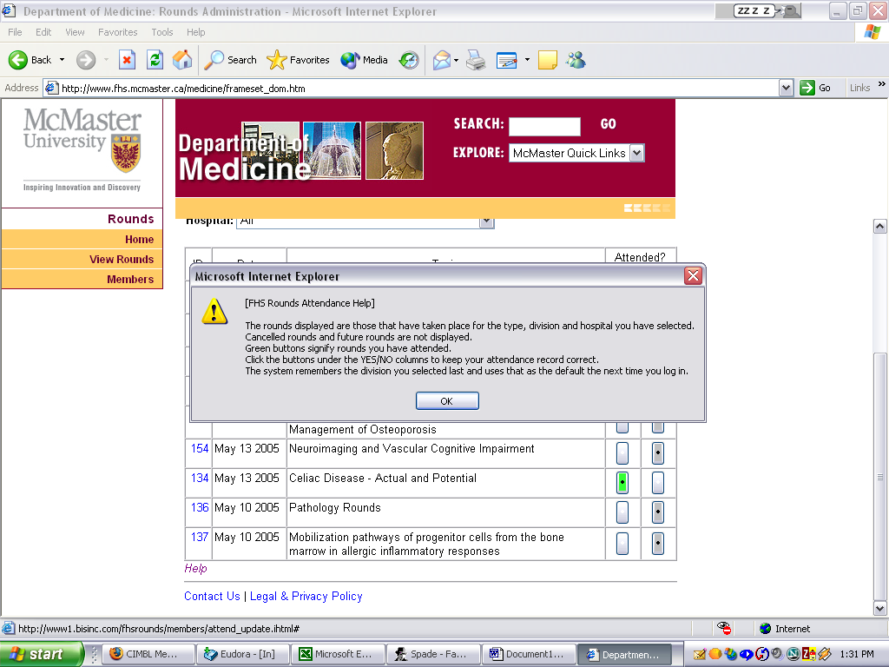
Once a Round has occurred, a member can report their attendance at that Round by using the Maintain Attendance Record screen. Click the Yes button to record your attendance, click the No button to correct an entry. When you click the Yes button, a text input box will open allowing you to submit comments on the Round. The comments are immediately emailed to the Division Admin responsible for that Round.

The system remembers which Division you have selected and defaults to that the next time you return to report attendance.

If attendance confirmation is required, an “X” will appear in that column. When attendance has been confirmed, a checkmark will appear in that column.

Clicking the Help link displays additional information for the Attendance system.

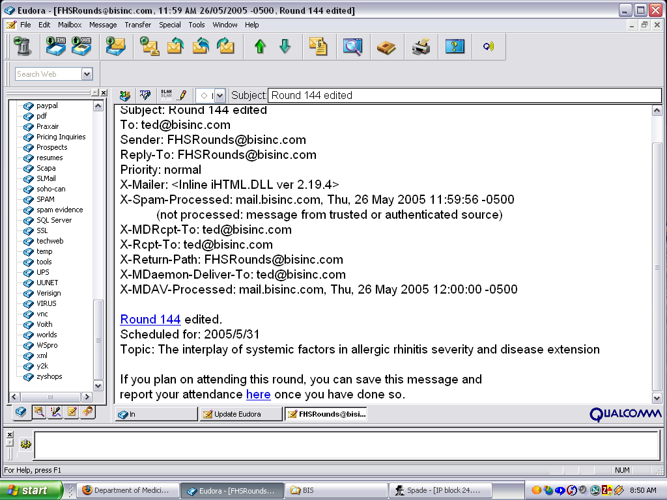

If your Messaging Options included email notification of Added and Edited Rounds, then you would have already received an email link directly to the attendance recording system for each specific Round when it was added or edited, allowing you to report your attendance with a single click.

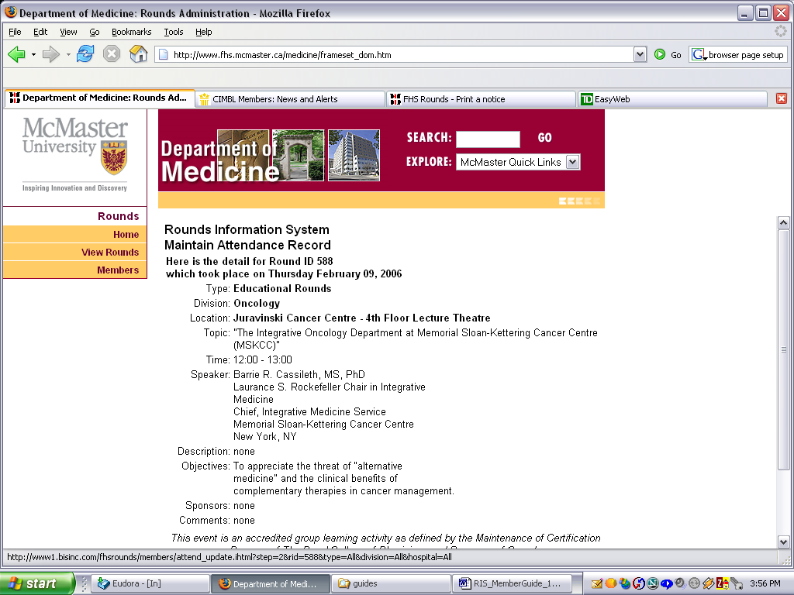
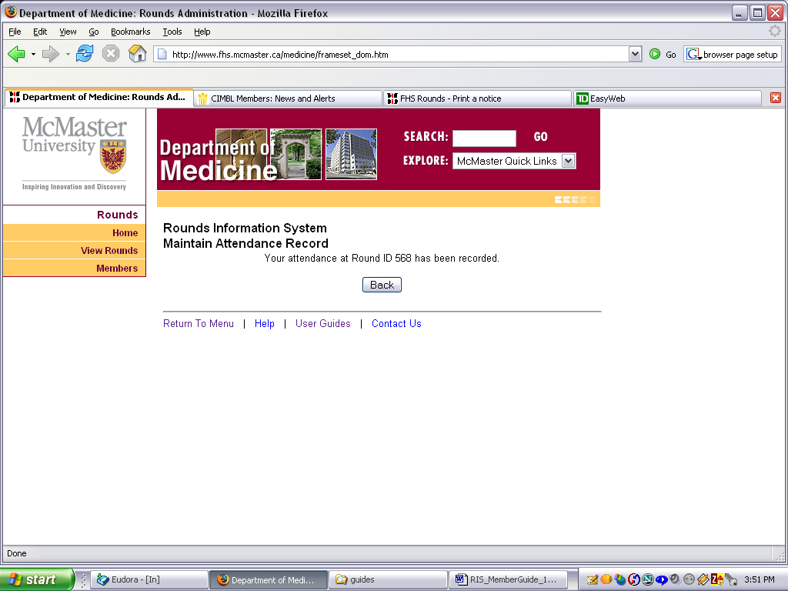

When you click the above link after having attended the Round, you will see the response shown on the right.

Full detail on any Round displayed can be seen by clicking on the Round ID link.

Similarly, once a Round has occurred, a member can report their performance of any roles at that Round by using the Maintain Roles Performed Record screen. Select a Role and then click the Yes button to record your performance of that Role, or click the No button to correct an entry.

The system remembers which Division the member selected and defaults to that the next time the member returns to report Roles performed.

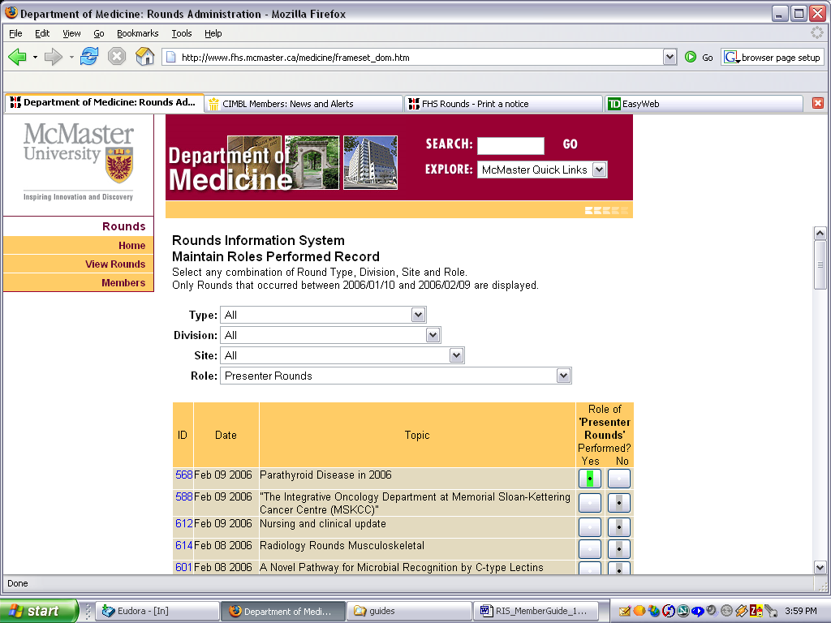

Clicking the Help link displays additional information for the Roles Performed records.

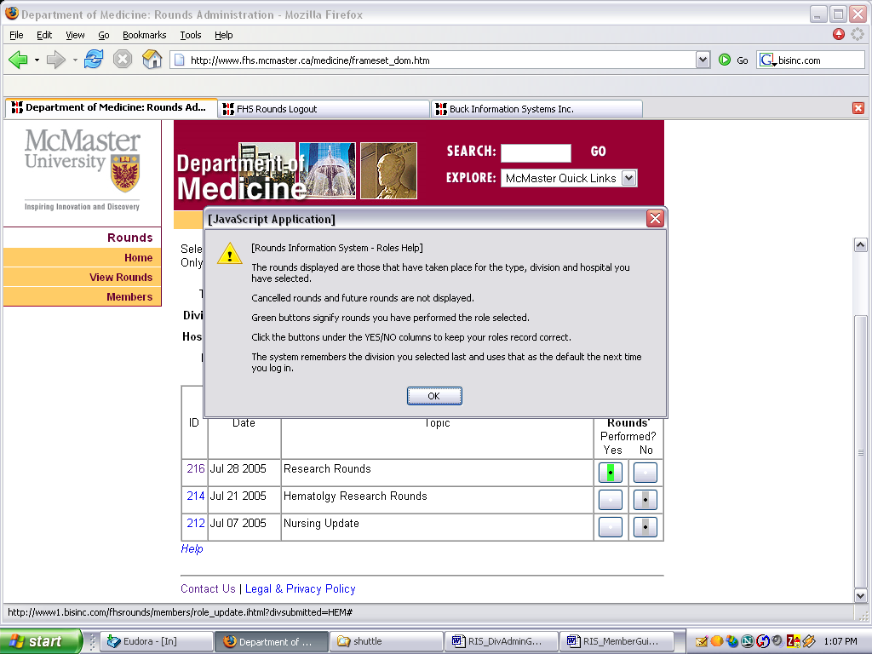

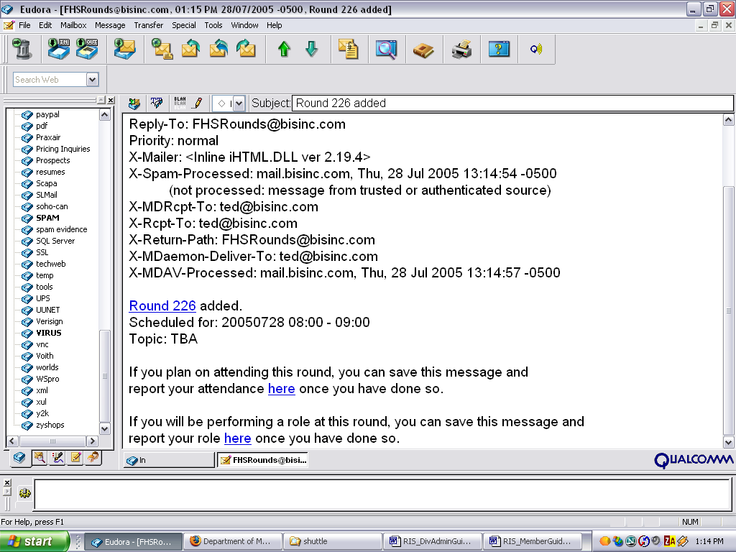
If your Messaging Options included email notification of Added and Edited Rounds, then you would have already received an email link directly to the roles recording system for each specific Round, allowing you to report your roles performed with little effort.

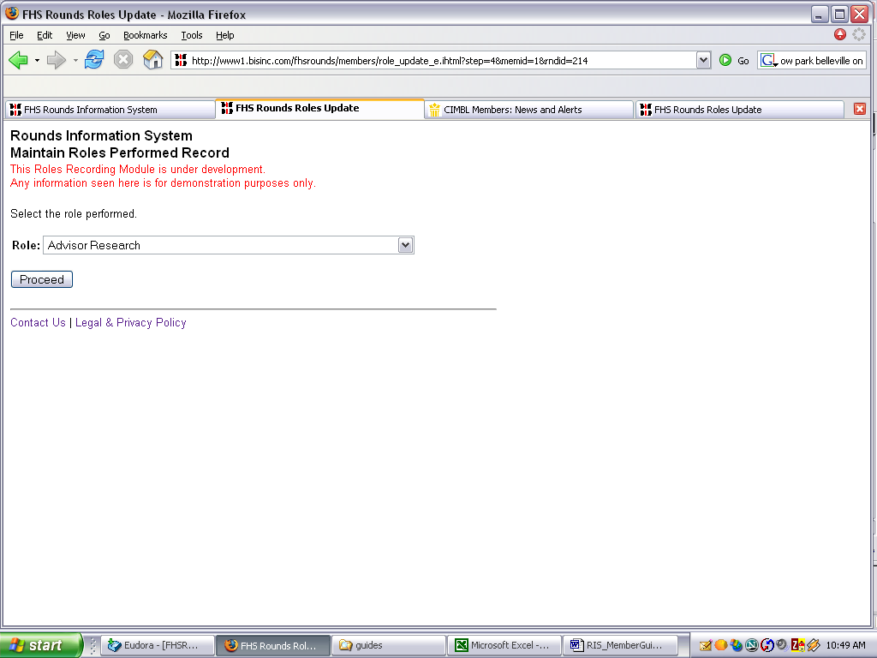
Simply select the Role performed from the drop down list and click Proceed…

That’s all there is to recording your attendance and role performance. At the bottom of each of those screens you will find links to attendance reports and role performance reports, allowing you to see your records for any calendar period

If you will be attending a Round that requires attendance confirmation, you should print an Attendance Confirmation Form for that Round and take it with you. Your Division Admin will be able to scan the form or key it into the system to confirm your attendance.
