Rounds Information System

System Administrator Guide

Certain members have Division Admin and/or System Admin accounts. Those with System Admin accounts will have a link to the System Admin Menu available on their Member Menu, as can be seen on the right.

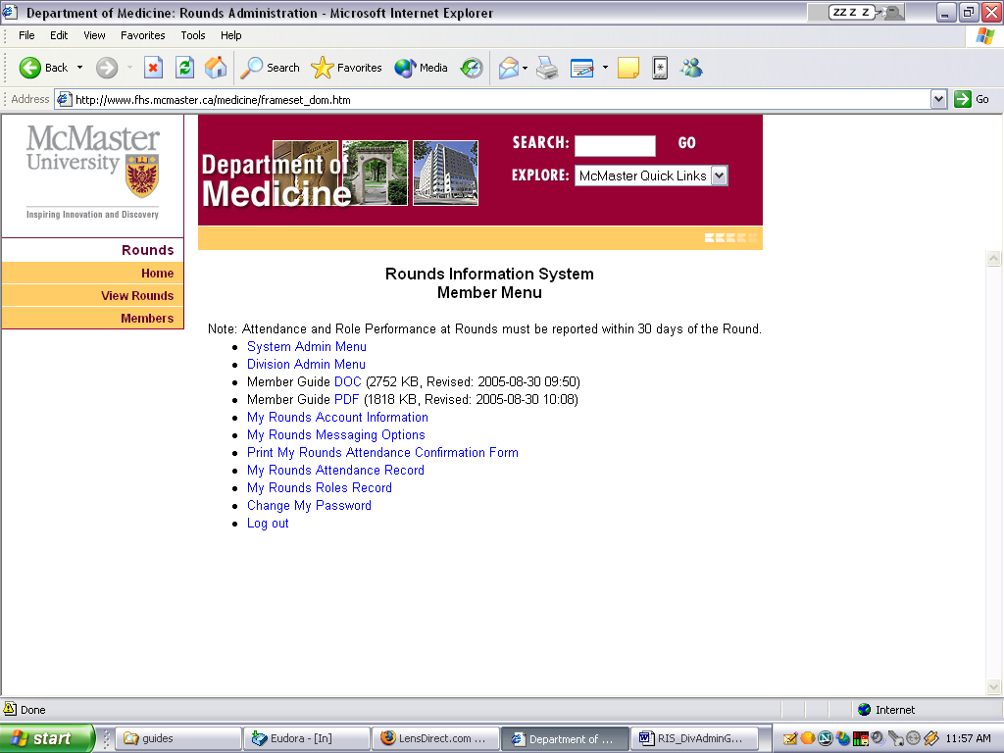

The System Administrator can manage the dynamic aspects of the site such as Disclaimers, Notes, Roles, attendance reporting etc. and can also modify some page content, for example to post messages on the welcome page, which is the first page members see when they log in.

The System Admin can also manage any member accounts and modify their configuration to assist a member who is having difficulty with any aspect of their account.

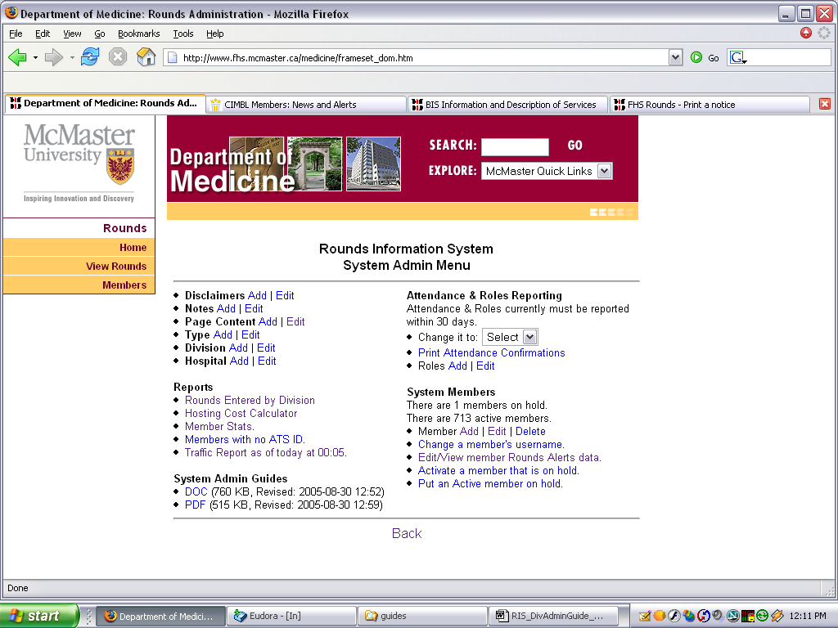

To add a member, the System Admin enters the member’s name, email address and a password and then selects a “handler” from the drop down list of Division Admins. The handler will be able to assist the member with the setup of their account. If “*No Handler*” is selected then the member must set up their own account.

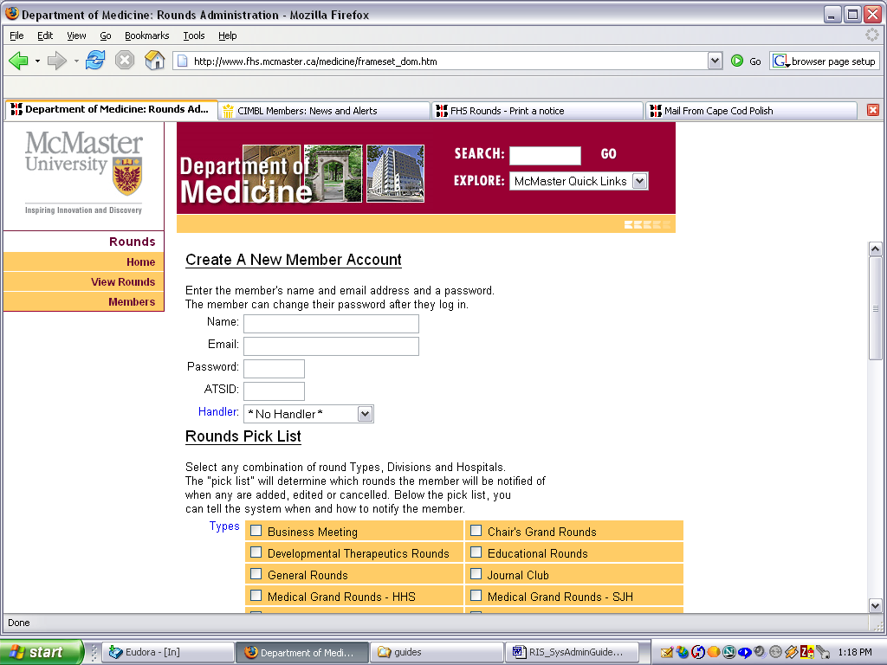
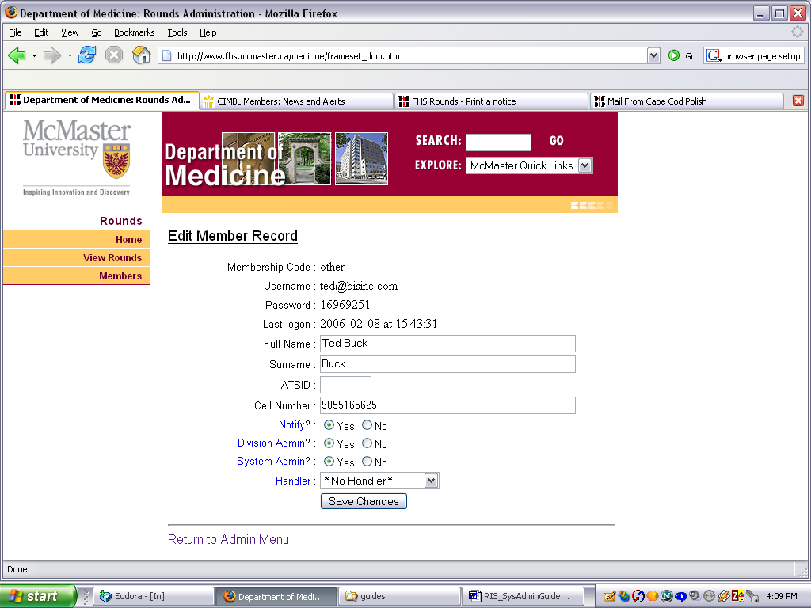
The System Admin can edit certain fields in the member’s record, including assigning Division Admin rights, assigning System Admin Rights and assigning (or removing) a Handler.

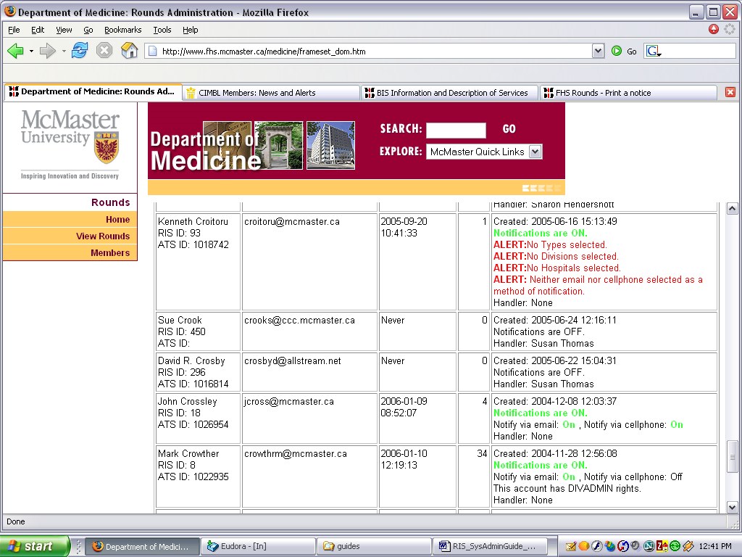
The System Admin can edit a member’s Rounds alerts setup and turn the notifications ON and OFF for any member. If the Round notifications are turned ON, the system will send an email to the member to inform them of the change.

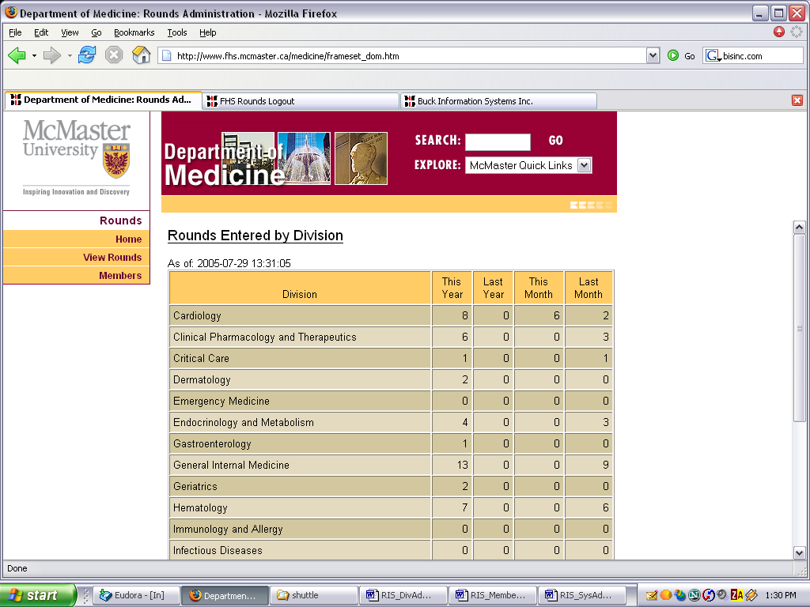
The System Admin can delete a member account, change a member’s username (email address) and apply and release holds to a member account.

If the member’s username is changed then the system will send an email to the member at their new address to confirm the change has taken place. Any bounced messages will be returned to the System Admin.

The System Admin can see rights, usage statistics and configuration anomalies for all member accounts.

A report displaying the number of Rounds entered by each Division is shown on the right.

The Traffic Report, generated every morning at 5 minutes past midnight, provides an extensive 12 page analysis of how the Rounds Information System is being used.
