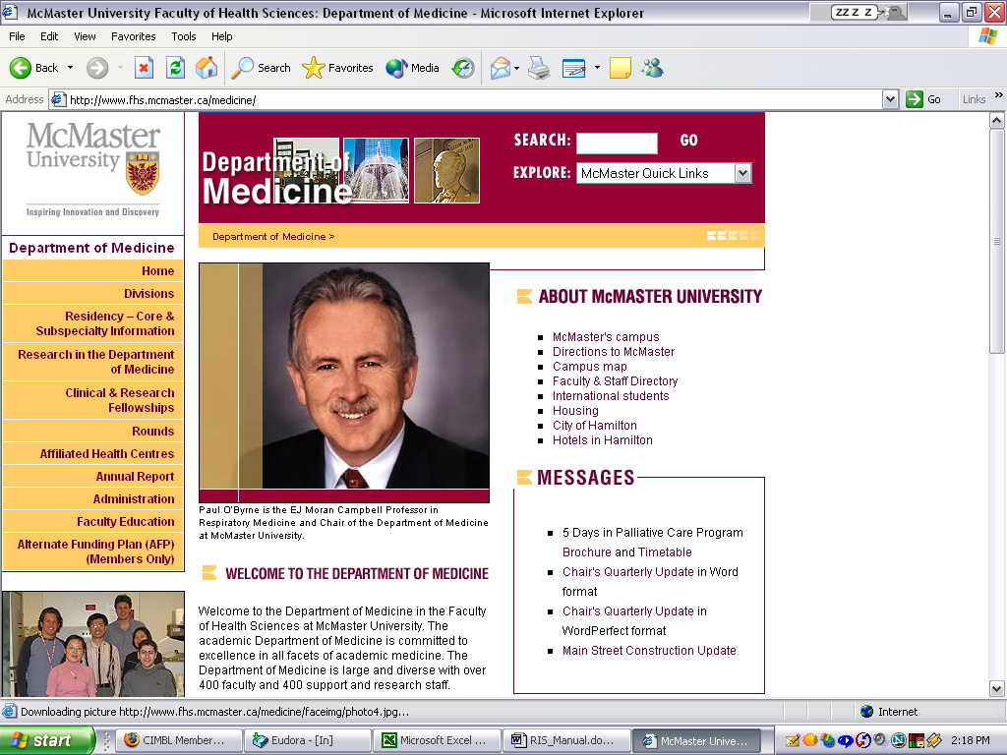
Rounds Information System

User Guide

The Rounds Information System can be accessed from the Faculty of Health Sciences department of Medicine home page by selecting the Rounds link or by selecting a Rounds link from within any Division home page.

Selecting Rounds from a division home page will default to that division’s Rounds.

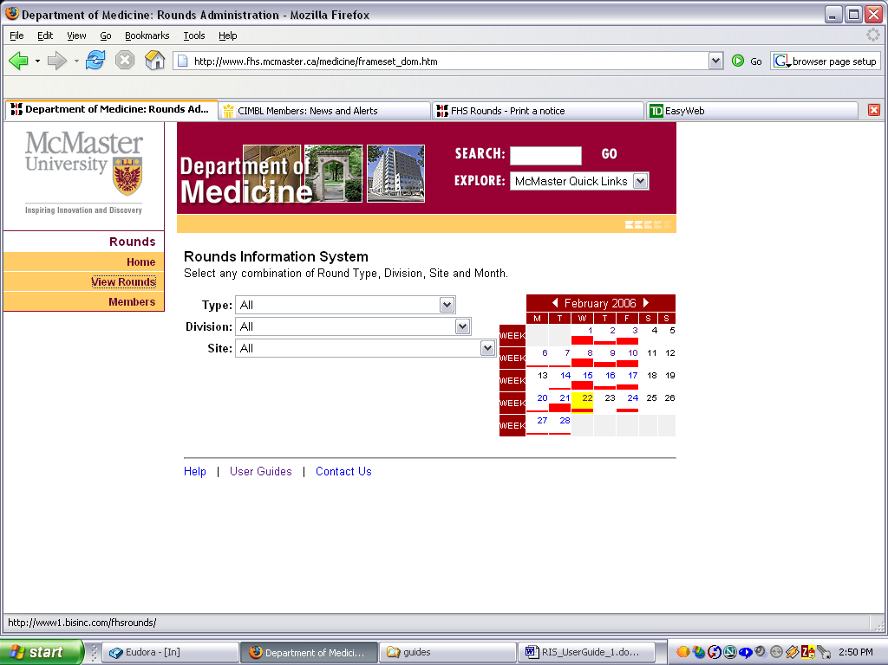
The default display from the Faculty of Medicine home page is for All types of rounds within All divisions within All sites, as shown on the right.

The calendar display indicates which days have rounds scheduled by showing a red bar on that day. The higher the red bar, the greater the number of rounds. A yellow background indicates that at least one round scheduled for that day has been cancelled.

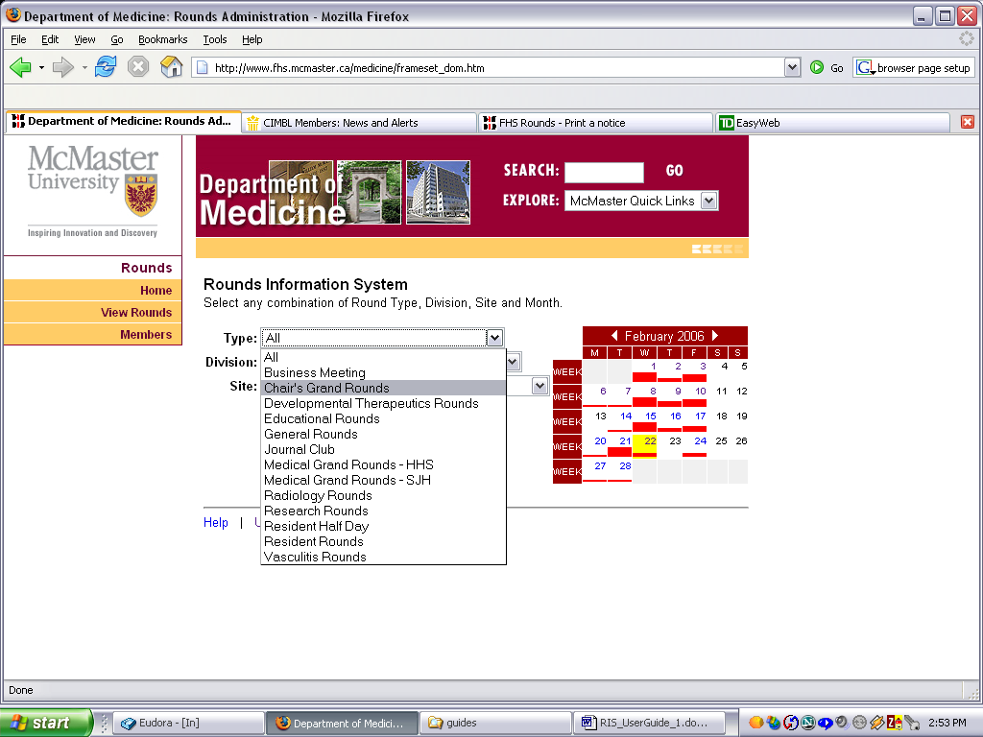

The user can select from the drop down lists to filter the displayed rounds by any combination of Type, Division and Site.

The calendar automatically reflects the filtering as each selection is made.
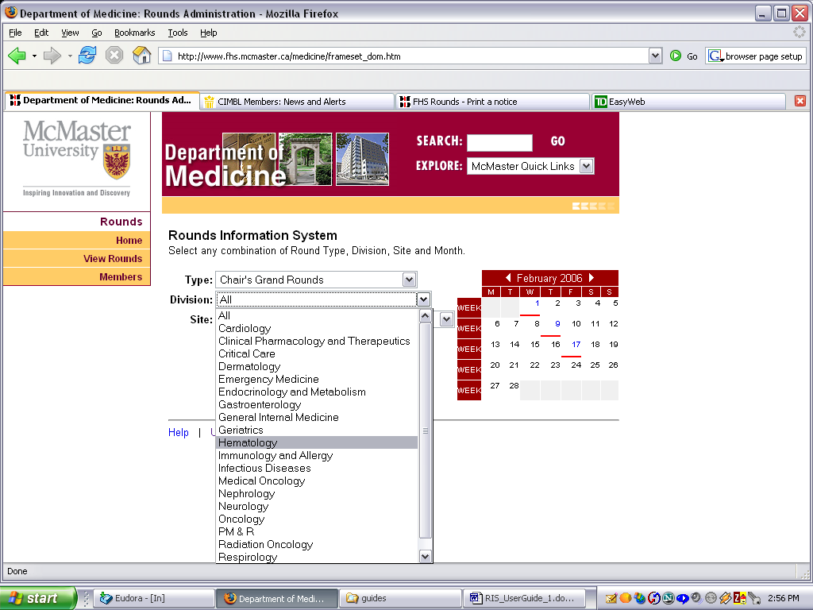

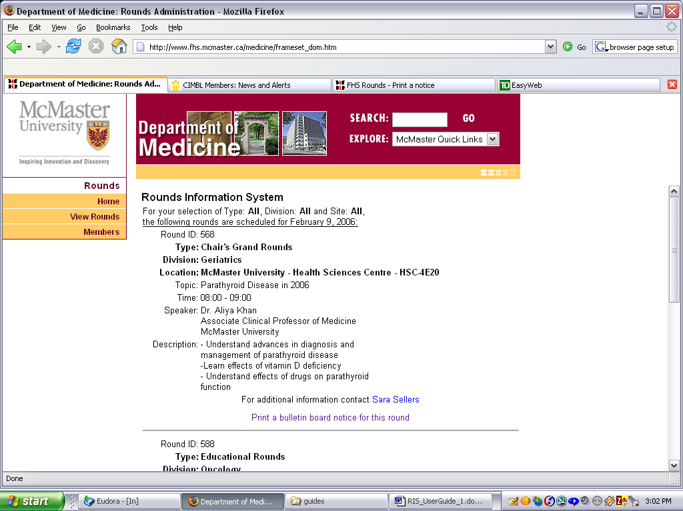

Clicking any date on the calendar which has Rounds scheduled will display the detail of all Rounds that are scheduled for that day.

Each round displayed has a link to provide a hard copy print for conventional bulletin board posting

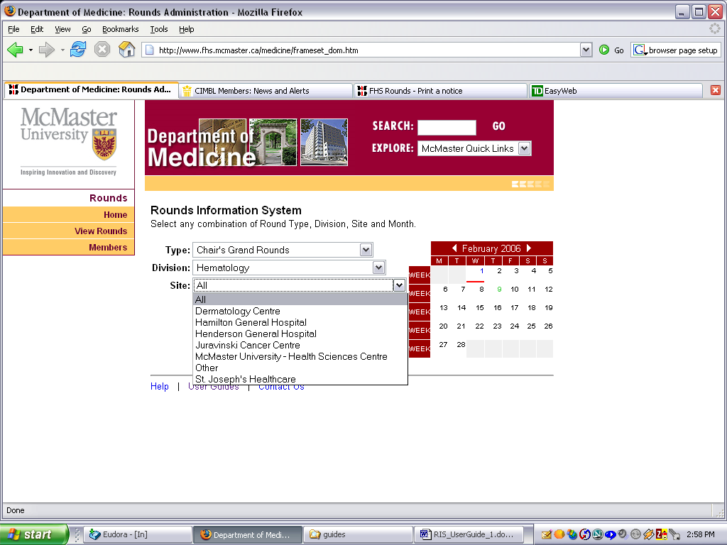

Clicking the printer icon will send the page to your local printer.

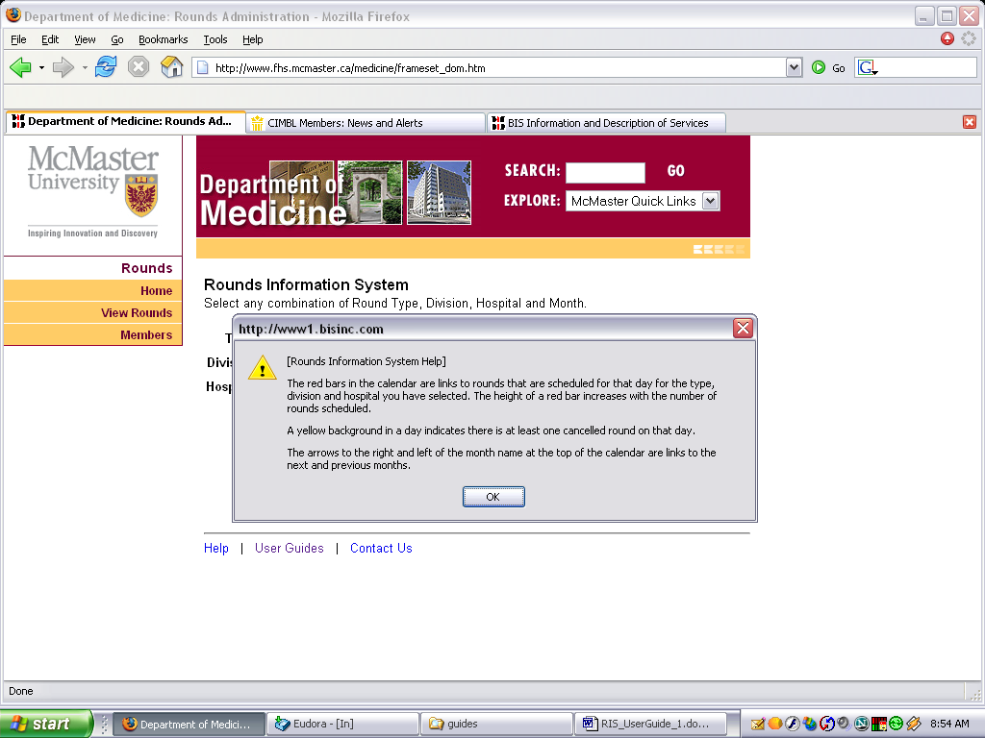

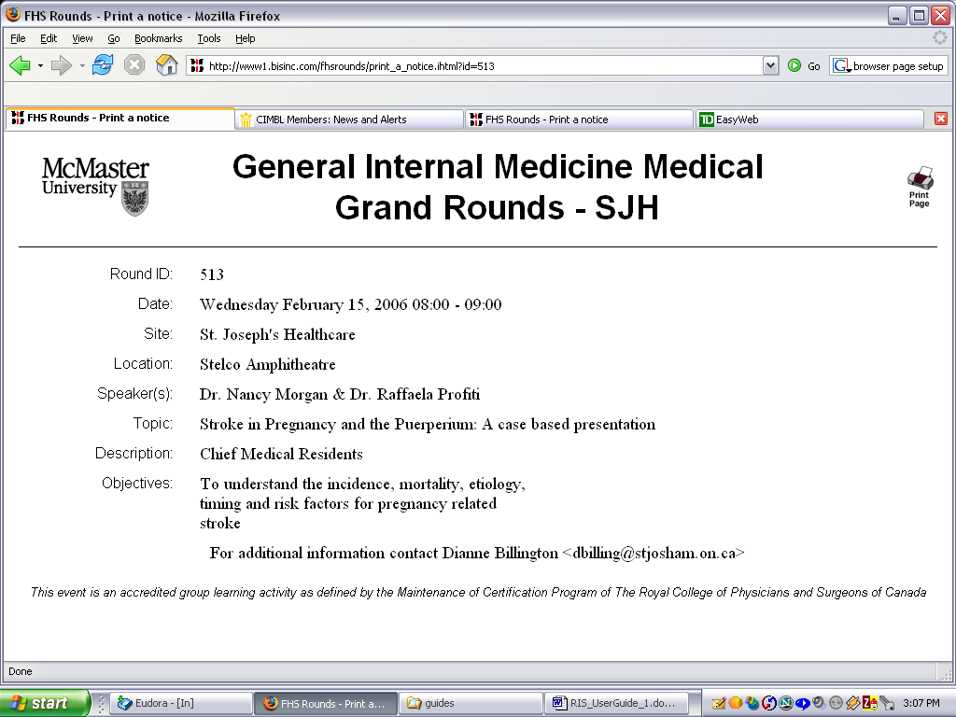

If the user clicks on a WEEK link in the calendar, then all rounds scheduled for that week are displayed.

Clicking Help at the bottom of the screen will display helpful information about the Rounds display.

Clicking User Guides will display a menu of all guides you can download.

Clicking Contact Us will present a feedback form where you can anonymously provide any comments, questions or suggestions.
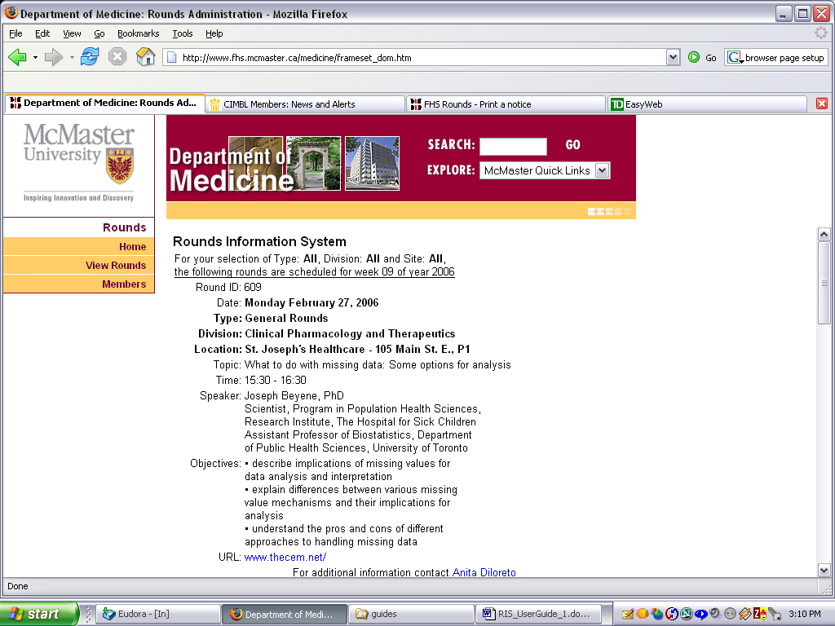

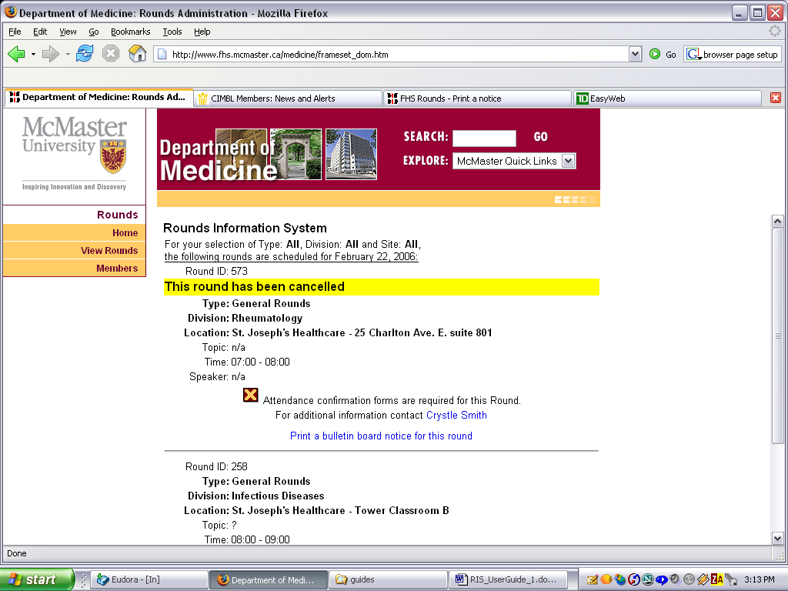
Any Round that has been scheduled and then subsequently cancelled will cause a yellow background to appear on the calendar on the date the round was originally scheduled to occur. The detail display for such Rounds will appear as shown on the right.

A highlighted bulletin board notice can also be printed to replace the original announcement.

